**New Decentralized ID based on Aadhar**

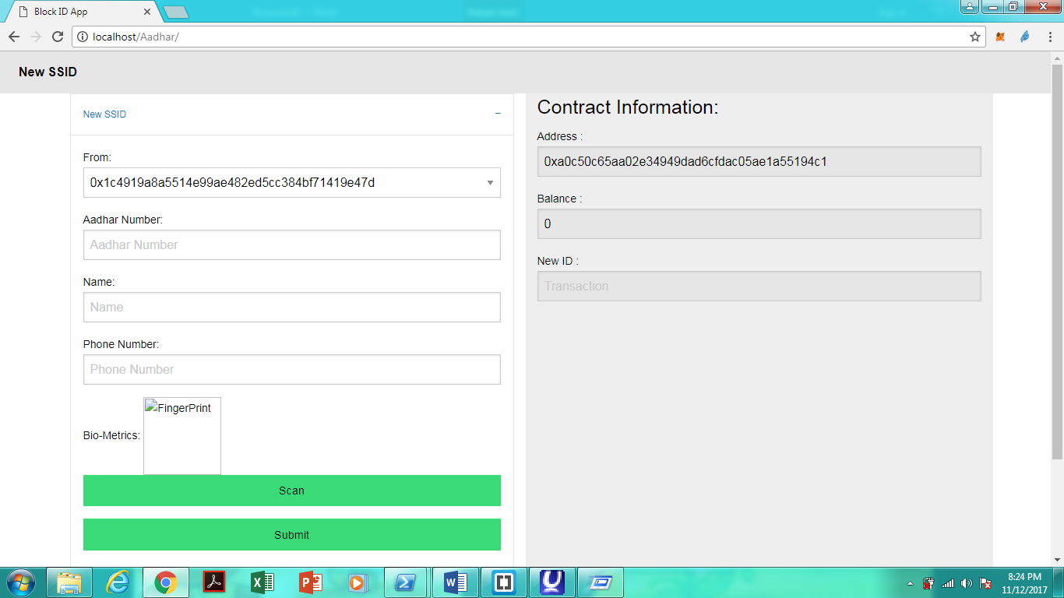

Left hand side aadhar information and ethereumn address

Right hand side smart contract information.

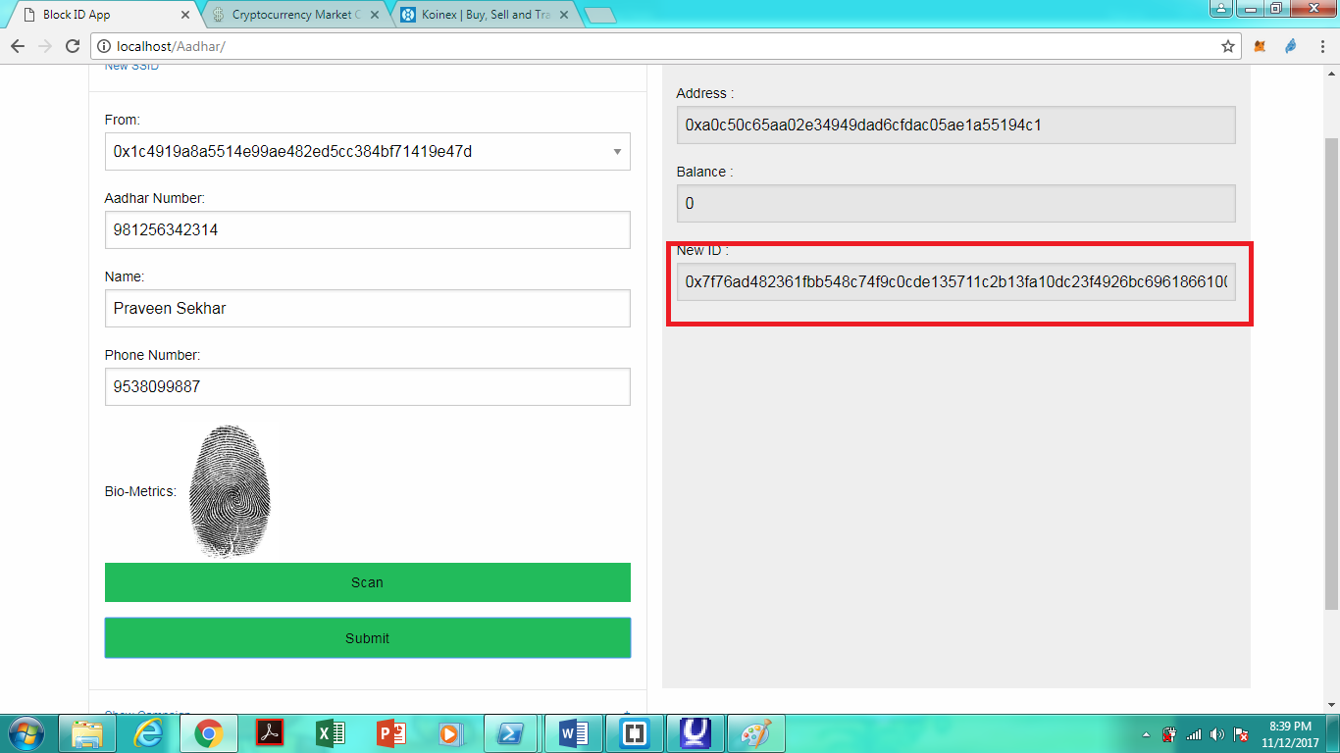

After Aadhar authentication of a user the Aadhar Number and Biometric data stored and attached to new Decentralized ID.

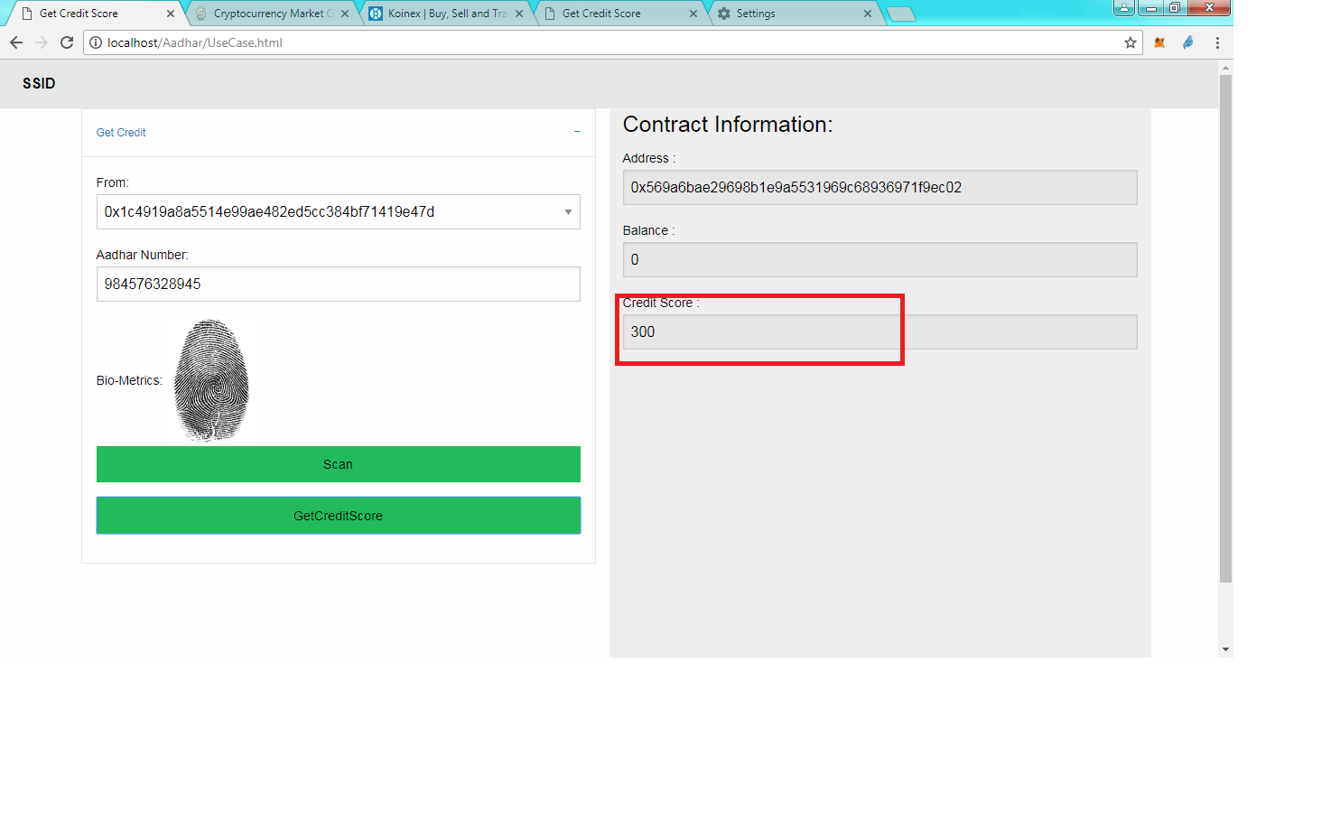

Credit score use case.

Ethereumn Techology Used:

* Solidity
* Truffle
* testrpc